Protect your files!

Hi, everyone. We, Trinity hackers, heard that last year some students cheated on their computer science assignments by accessing and copying others' code. To prevent this from happening again, we urge your to change the file permission of your home folder. The default permission of your home folder is set to 755, which means that anyone can see and read your files.
To stop others from accessing your files is easy. Simply do the following steps. (If you are good at command line you can jump to page 4 and save some time).

1. Open your home folder, right click on “Home” and select “Properties”.

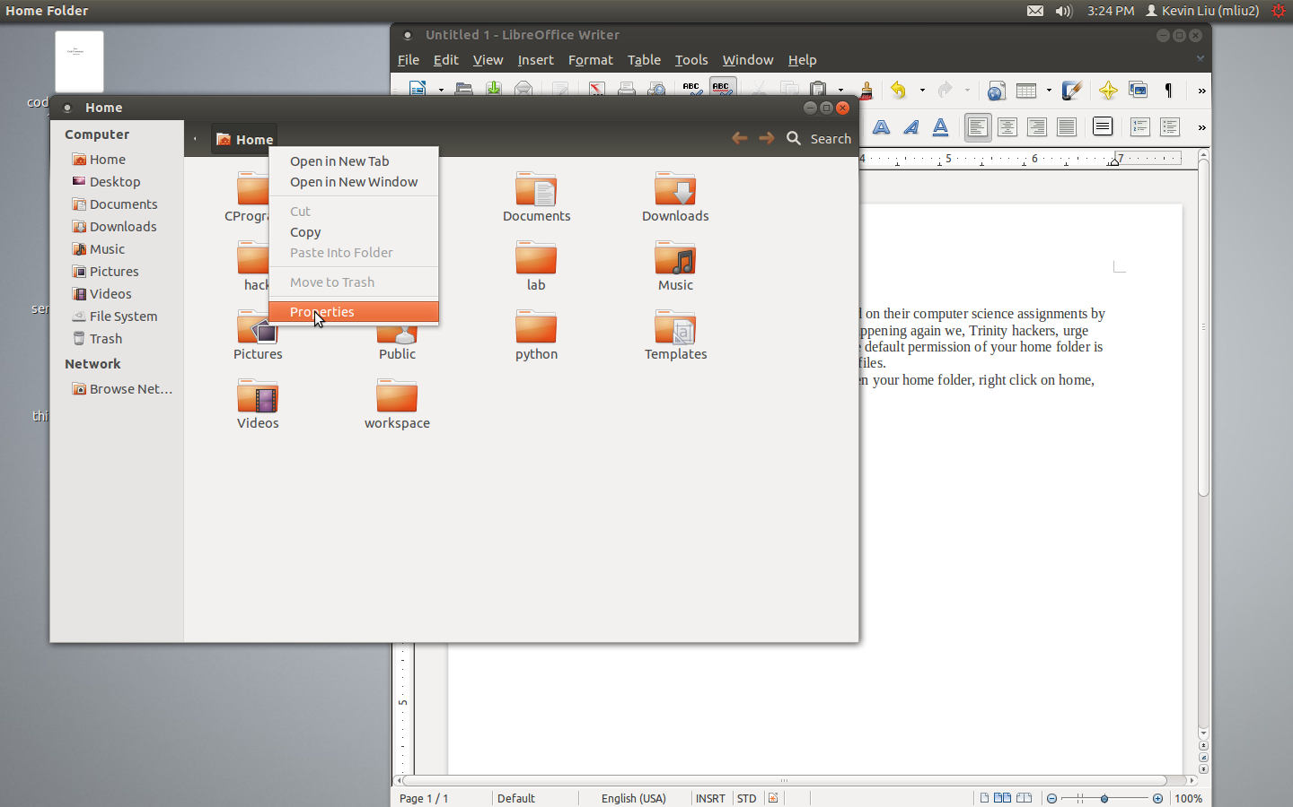

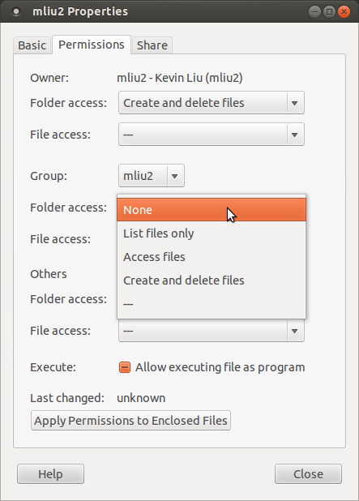
2. In the Properties window, select “Permissions” tab.

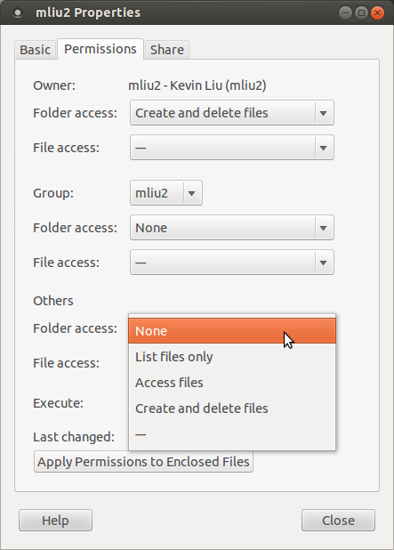
3.Change “Folder access” of “Group” to “None”.

4. Do the same thing for “Others”.
5. Close the window and your files are now protected!

If you want to do it in a COOLER way, you can open your Terminal and enter the following command.

cd .. ; chmod 700 your_login_name

Replace your_login_name with your user name on lab computers. Don't forget the space between cd and the two dots.
Hit enter and if you typed everything correctly you should see another prompt.
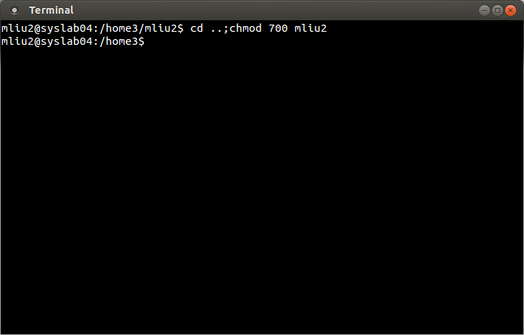
Congratulations. No one can see or access your files now.

Best regards,
Trinity Hackers Community

